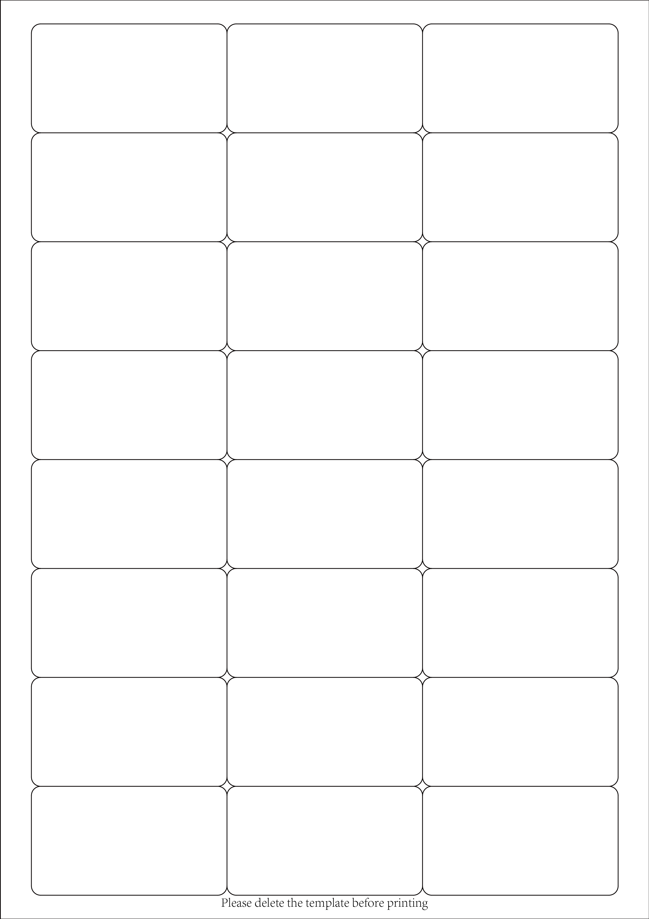

Edit text

Edit text

Edit text

Edit text

Edit text

Edit text

Edit text

Edit text

Edit text

Edit text

Edit text

Edit text

Edit text

Edit text

Edit text

Edit text

Edit text

Edit text

Edit text

Edit text

Edit text

Edit text

Edit text

Edit text