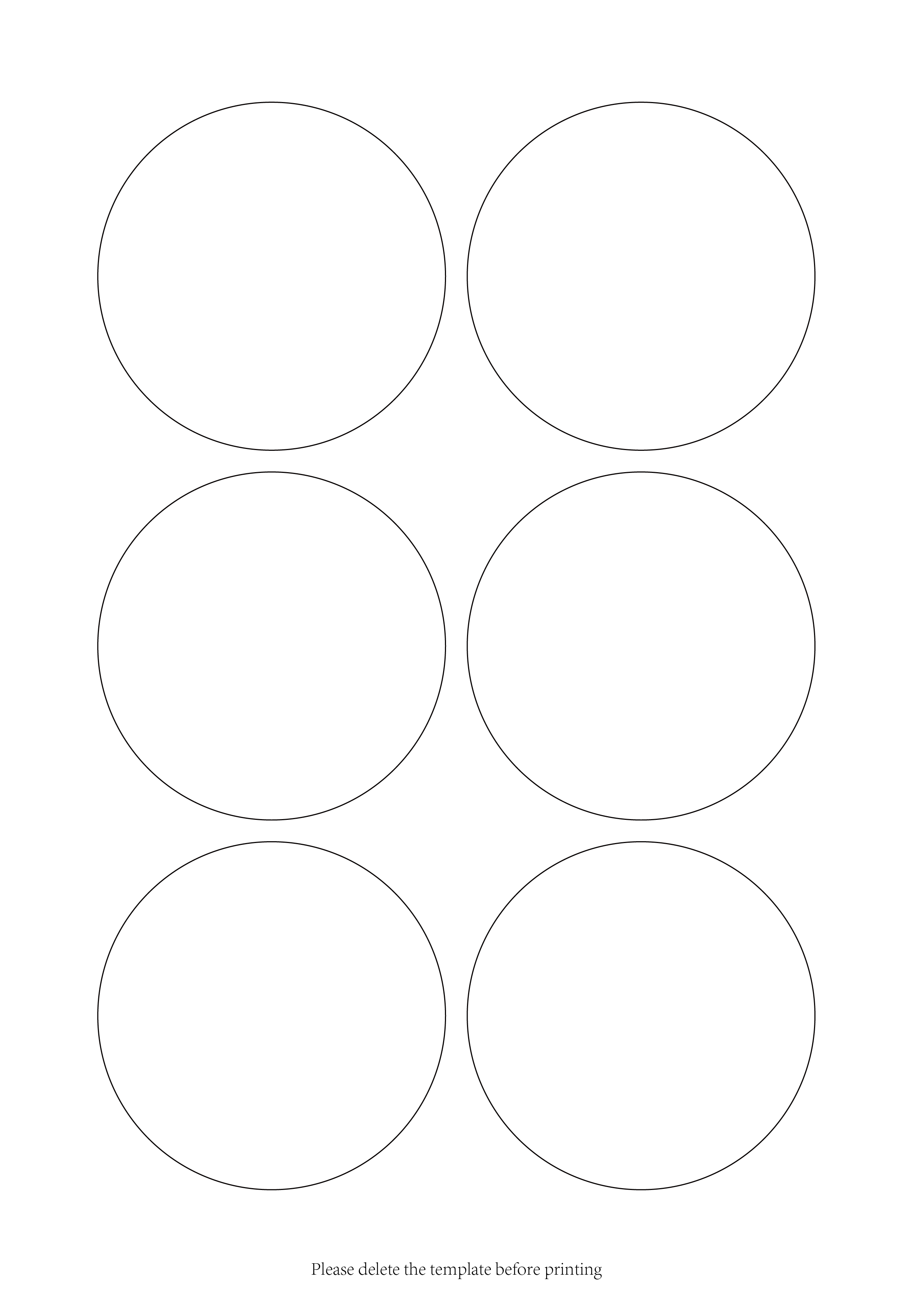

Edit text

Edit text

Edit text

Edit text

Edit text

Edit text